**Auto-Ranging OhmMeter Project**

**B EE 425 Microprocessor System Design**

**Students: Patrick Banez and Gabe Hearon**

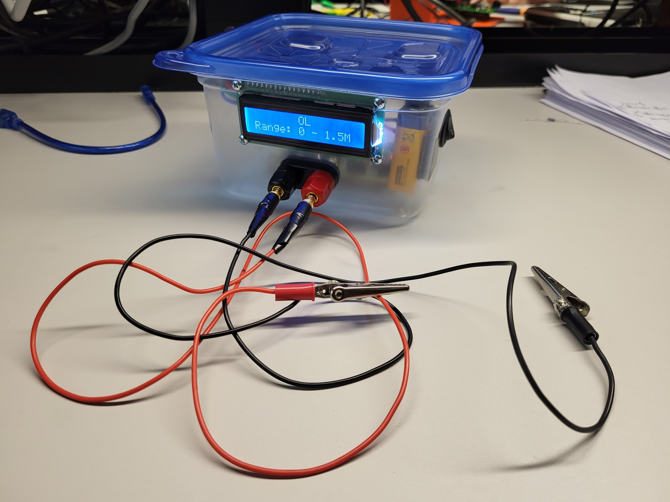

**Table 1 - Ohm Meter Operating Specifications**

| **Input Voltage** | **9 VDC** |
| --- | --- |
| **Battery Life** | **~7 Hours** |
| **Measurement Range** | **100 mΩ - 1 MΩ** |

**Parts and Materials**

See **Table 4** for all the parts used in the system, excluding the case.

**Overview**

This ohm meter project will consist of a 5 volts reference voltage, an external 16-bit ADC, 4 MOSFETs for switching, 5 parallel resistors, and an Arduino nano.Using Ohm’s law ($V=IR$) and a voltage divider ($Vx=Vs*[Rx/Rt]$), the resistance of the unknown resistor will be calculated. The unknown resistor’s value can range from 100mΩ to 1 MΩ.

The voltage will be measured through a 16-bit ADC, calculations will be performed on the Arduino, and then the resistance result will be displayed on an LCD. The Arduino, ADC, and display will communicate via I2C connections using their SDA and SCL pins. Measurements displayed will be autoranging and will be 3-½ digits. For power, the ohm meter will use a 9 volt battery.

**Goals and Requirements**

The goal of the ohm meter is to precisely measure a resistor’s value meeting the following specifications:

* Battery operated, or from 5V wall power supply
* Auto-ranges for best accuracy over 1 ohm to 1 mega-ohm resistance range
* Resolution 3-1/2 digits (0000 - 1999)
* Accuracy 1 ohm and 1 mega-ohm ranges 1%
* Accuracy: 10 ohm and 100 kilo-ohm range 0.1%
* All other ranges 0.05%
* Minimum update frequency 5 updates per second
* Operate independently from a PC or laptop
* Have attached flying leads with alligator clips to attach to the unknown resistor

**Schematic and Printed Circuit Board**

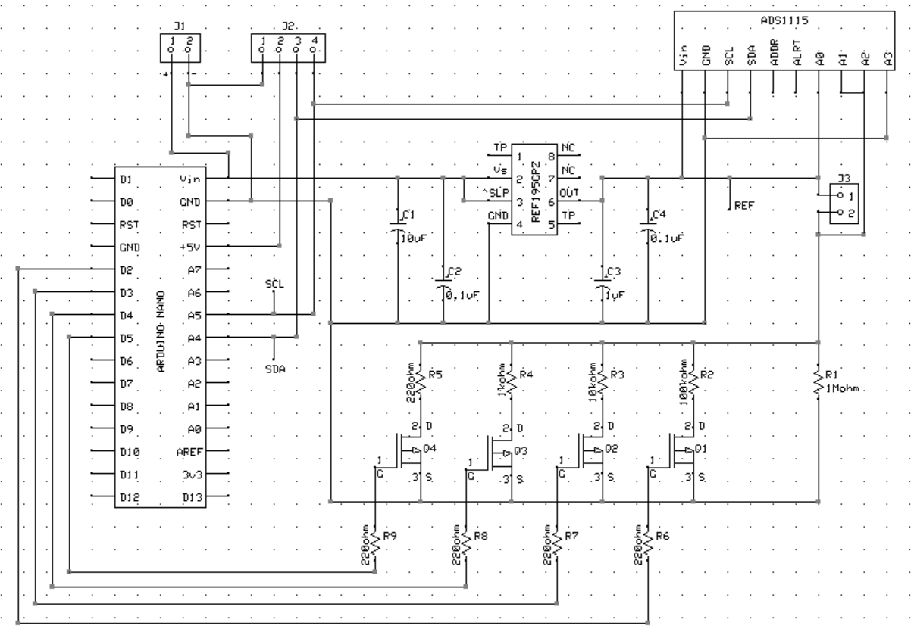

**Figure 1 - Ohm Meter Schematic**

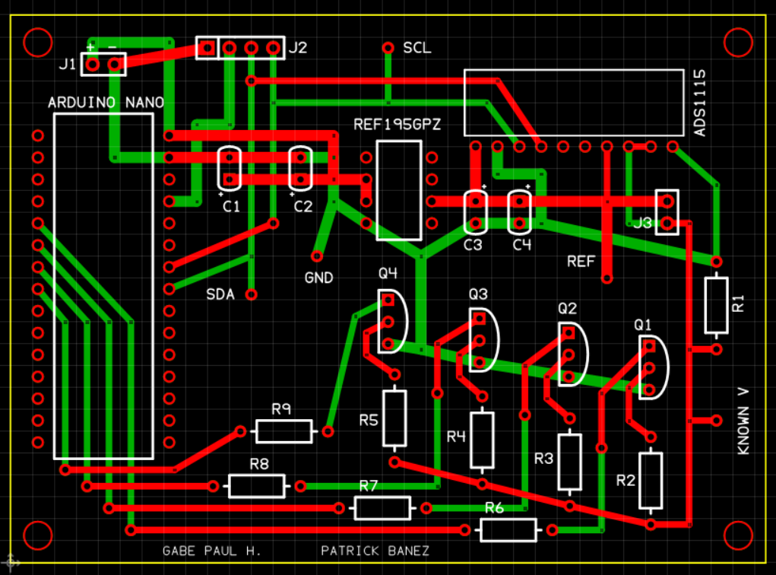

**Figure 2 - Printed Circuit Board Design (PCBExpress)**

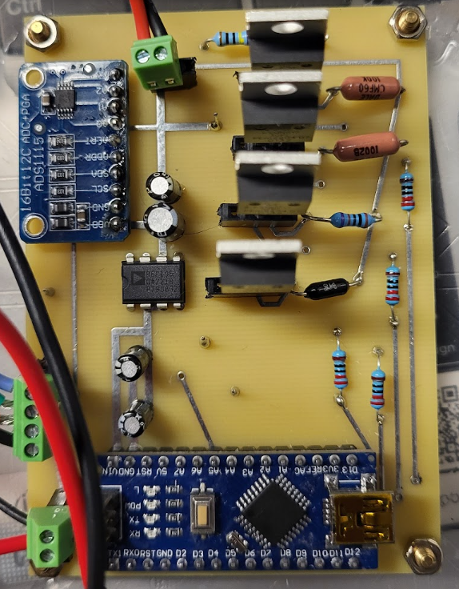

**Figure 3 - Actual Printed Circuit Board**

**Theory of Operation**

The unknown resistor will be placed in series with a known resistance value and the current can be calculated by measuring the voltage across the known resistance and using the voltage divider formula, ADC, and Arduino. After the current is calculated, the voltage drop across the known resistance will be measured. Since we know the voltage drops of both resistors and the current flowing through the branch we can use Ohm’s Law($R=V/I$) to calculate the value of the unknown resistor.

We have placed 5 known resistors in parallel, with each resistor in series with a MOSFET acting as a switch. The MOSFET will add or remove resistors in parallel to increase or decrease the known resistance value used to calculate the current through the unknown resistor. The value of the resistance will range from 176 Ω to 1 MΩ by switching on and off the MOSFETs. The MOSFETs will be turned on via an output voltage from pins D0 through D3 on the Arduino Nano. Deciding when to turn on the MOSFETs will be determined by the voltage reading across the known resistance at pin A1 of the ADC. If the voltage at A1 is too close to the voltage ceiling of 5 V (meaning there is little to no voltage drop on the unknown resistor), then the MOSFETs will turn on by bringing the D0 through D3 pins high on the Arduino to decrease the known resistance. If less than 2 V is measured on the known resistance, the MOSFETs will turn on until at least 2 V is measured or all the MOSFETs have been turned on. The 2 V is arbitrary and can be replaced with any other value between 0 V and 5 V.

**Software**

The software was written with C++ using the Arduino IDE. The software loops infinitely performing the following actions: reading voltages, calculating current, calculating resistance, and then displaying the calculated resistance. Our external ADC and LCD had library code that we were able to use instead of writing our own code. The library code we used was from “Adafruit_ADS1X15.h”, “Wire.h”, and “LiquidCrystal_I2C.h”.

We used the ADC’s differential sampling mode to read the difference between the ADC’s analog pins. Pins A0 to A3 measured the reference voltage, pins A0 to A1 measured the unknown resistor’s voltage, and A2 to A3 measured the known resistor’s voltage. The “Adafruit_ADS1X15.h” library provided us with the differential sampling function which returns the ADC value for the difference between 2 pins. The ADC value was used as input to the same library’s computeVolts() function which returns the voltage value represented by the ADC value.

Our autoranging and gain-adjustment capabilities are also included in our readVoltages() method. Resistors are added in parallel when the voltage of the known resistor is greater than 75% of the reference voltage. A while loop is used to add resistors in parallel until either the voltage of the known voltage is below 75% of the reference voltage or there are no more resistors to add in parallel. For more accurate measurements, we auto-adjusted our ADC’s gain by comparing the unknown resistor’s voltage with the various acceptable voltage ranges for the ADS1115’s gain factors.

Using the known resistor’s voltage, we calculated the current through the known resistor using Ohm’s Law. Since the known and unknown resistors are in series, the current is equal through both. With the calculated current, we used Ohm’s Law and the unknown resistor’s voltage to calculate the unknown resistor’s resistance value.

We set our measurement rate to 1000 Hz taking a running average and our display rate to 10 Hz. Our range of measurements are from 100mΩ to 1.5 MΩ. For displaying purposes, if the unknown resistance value is calculated to be less than 0 Ω or greater 1.5 MΩ then the “OL” will be displayed on the LCD. The “LiquidCrystal_I2C.h” library provided us with code for displaying the measurement.

**Decision Choices**

We chose to use an Arduino Nano because we have some experience with the Arduino Uno. The Nano has a much smaller profile than an Uno, which makes the Nano more ideal for portable projects. For communication, we can use the Nano’s I2C pins (A4 and A5) to communicate with the LCD and ADC using only 2 wires.

To accurately measure the resistance, we used a 5V voltage reference . A voltage reference can produce a consistent output voltage regardless of variations (to an extent) to the input voltage. The REF195GPZ 5 V reference voltage is capable of outputting 5 volts and 30 mA.

Since the maximum current output of the REF195GPZ is 30 mA, a minimum of about 167 Ω is needed to to limit the current to 30 mA at 5 V. We chose to use about 178 Ω which limits the current to about 28 mA; this way we can utilize the full current range of the reference voltage. The 178 Ω comes from 5 parallel resistors, which is equal to about 177 Ω, and a minimum unknown resistor value of 1 Ω. If a resistor of less than 1 Ω is placed in the circuit, the output current of the reference voltage is still limited to about 28 mA because of the 177 Ω from the parallel resistors. We chose to use the same capacitor filter configurations as the one in the datasheet for the REF195GPZ.

The Arduino Nano has a built-in 10-bit ADC which provides a voltage resolution of about 4.88 mV using a 5 volt reference. We decided to use an external 16-bit ADC, the ASD 1115, for more voltage resolution. The 16-bit ADC provides a voltage resolution of about 76.3 µV; with the 16-bit ADC the range will be from 0 to 65,535.

For the switches that determine the known resistance, we chose to use the PSMN017-30PL MOSFET because of its fast switching speed, low VGS (4.5V), and low on resistance (23.4 mΩ). The MOSFET will negligibly affect the value of the known resistance, but we took the on resistance into account when doing the current calculation. To turn on the MOSFET, the digital pins of the Arduino will be used to provide 5V at the gate of the MOSFET and connect the resistors to ground.

The LCD we used was a GeeekPi 16x2 display that we had on hand from an Arduino kit. Our LCD can connect to our circuit via I²C along with our ADS1115. The I²C pins on the Arduino Nano are A4 (SDA) and A5 (SCL).

**Testing**

In terms of testing the design throughout the PCB assembling, we used test points on the PCB to measure important values. In particular the reference voltage test point and the known resistance voltage test point were useful. Throughout the construction we would build sections such as the voltage divider and test it before assembling more parts to make the process as easy as possible.

To test the ohm meter’s readings to specifications, we measured the resistance of a metal-film resistor using lab bench #9’s ohm meter in the lab at UW Beardslee. After taking that measurement with the lab ohm meter, we used our ohm meter to take a measurement. Our ohm meter measurements and the lab ohm meter measurements should, ideally, be the same. See the **Appendix** for photos of our test measurements.

**Table 2 - Data from Test Measurements vs Our Ohm Meter Measurements**

| **Nominal value** | **1 Ω** | **10 Ω** | **100 Ω** | **1 kΩ** | **15 kΩ** | **150 kΩ** | **1 MΩ** |
| --- | --- | --- | --- | --- | --- | --- | --- |
| Known resistance | 0.986 Ω | 10.028 Ω | 98.52 Ω | 0.9798 kΩ | 14.8 kΩ | 150.5 kΩ | 0.991 MΩ |
| Measured resistance | 0.99 Ω | 10.03 Ω | 98.47 Ω | 0.979 kΩ | 14.788 kΩ | 150.1 kΩ | 0.986 MΩ |
| Percent Error | 0.41% | 0.02% | 0.05% | 0.08% | 0.08% | 0.27% | 0.50% |

**Table 3 - Data for the 3 Resistors Tested by Prof. Decuir**

| **Known Resistance** | **12.152 kΩ** | **5.12 Ω** | **0.9756 MΩ** | **0.090 Ω** |
| --- | --- | --- | --- | --- |
| Measured Resistance | 12.15 kΩ | 5.114 Ω | 0.979 MΩ | 0.091 Ω |
| Percent Error | 0.02% | 0.12% | 0.35% | 1.11% |

**Design Cost**

**Table 4** includes all parts that were used in our ohm meter design. The total price of our ohm meter using the listed supplies was *$60.89*, not including the shipping cost of the parts.

**Table 4 - Bill of Materials**

| **Part Number** | **Item Name** | **Quantity** | **Price ($)** |
| --- | --- | --- | --- |
| [584-REF195GPZ](https://www.mouser.com/ProductDetail/Analog-Devices/REF195GPZ?qs=WIvQP4zGani0jPrITEAMJg%3D%3D&countryCode=US&currencyCode=USD) | 5 V Reference | 1 | 6.77 |
| [771-PSMN017-30PL,127](https://www.mouser.com/ProductDetail/Nexperia/PSMN017-30PL127?qs=J5yRED2HLPS3ZPrb9AelsQ%3D%3D&countryCode=US&currencyCode=USD) | MOSFET | 4 | 5.60 |
| [594-MBB0207VD1004BC1](https://www.mouser.com/ProductDetail/Vishay-Beyschlag/MBB0207VD1004BC100?qs=sovQiknVfn0V3oItqsAj7g%3D%3D&countryCode=US&currencyCode=USD) | 1MΩ 0.1% 0.6W Resistor | 1 | 0.66 |
| [71-CMF60100K00BEBF](https://www.mouser.com/ProductDetail/Vishay-Dale/CMF60100K00BEBF?qs=A%252B%2FNCR0PvNUCkjDLIguObQ%3D%3D&countryCode=US&currencyCode=USD) | 100kΩ 0.1% 1W Resistor | 1 | 2.86 |
| [71-RN60E-B-10K](https://www.mouser.com/ProductDetail/Vishay-Dale/RN60E1002BB14?qs=9AX3phJxokX8XHLLjNPA6A%3D%3D&countryCode=US&currencyCode=USD) | 10kΩ 0.1% ¼W Resistor | 1 | 1.89 |
| [279-YR1B1K0CC](https://www.mouser.com/ProductDetail/TE-Connectivity-Holsworthy/YR1B1K0CC?qs=VHcS2MTj4gZxEjx26j5Z6Q%3D%3D&countryCode=US&currencyCode=USD) | 1kΩ ¼W Resistor | 1 | 0.62 |
| [571-5-1879642-9](https://www.mouser.com/ProductDetail/TE-Connectivity-Holsworthy/5-1879642-9?qs=IZrxGxQQvkMiSVxBYfOGZQ%3D%3D&countryCode=US&currencyCode=USD) | 220Ω 0.1% Resistor | 1 | 1.56 |
| Arduino | Nano V3.0 | 1 | 8.00 |
| ADS 1115 | 16-bit ADC | 1 | 5.00 |
| GeeekPi | 16x2 LCD | 1 | 5.50 |
| Molence | PCB Screw Terminal (2 pin) | 2 | 0.64 |
| Molence | PCB Screw Terminal (3 pin) | 1 | 0.32 |
| Hilitchi | Banana Plug & Jacks | 1 | 0.83 |
| WMYCONGCONG | Metal Alligator Clips | 2 | 0.55 |
| BOJACK | 10 µF Capacitor | 1 | 0.03 |
| BOJACK | 1 µF Capacitor | 1 | 0.03 |
| BOJACK | 0.1 µF Capacitor | 2 | 0.06 |
| APIELE | Rocker Switch | 1 | 0.90 |
| Amazon Basics | 9V Battery | 1 | 1.57 |
| — | 9V Battery Connector | 1 | 0.50 |
| PCB Express | Custom PCB | 1 | 17.00 |
| — | 20 AWG Wire | ~6 ft | — |
| **Total** | — | — | **60.89** |

**Conclusion**

Our ohm meter design was able to measure resistance values fairly well within the tolerance requirements. The ohm meter is battery operated, auto-ranges for different ohm ranges, operates freely without a PC connection, has a 1000 Hz measurement rate, 10 Hz display rate, and has flying leads with alligator clips to attach to an unknown resistor. We were able to meet all the requirements except for the 3 ½ digits display, but we were still displaying the correct values.

**Reflections**

Overall our ohm meter project was successful for the ranges that were listed in the project specifications. We did extra work and improved the low end measurements of the meter to about 100mΩ and made a case to go with it. However, there were a couple of things we could definitely improve the meter with.

One of our biggest limitations was not changing the display to be 3 ½ digits and showing more significant digits at the lower end readings. For reference our ohm meter measured pretty well at the low end but it was confined to three significant figures. This meant that with a measurement of 91mΩ we could only measure either 90mΩ, 91mΩ or 92mΩ. Our design definitely had enough precision to differentiate to a smaller amount than this, and we could definitely go back and code it to show this. Because of this design aspect, our low end measurement would be really accurate if the value was slightly above 100mΩ but if it was below more uncertainty was introduced.

Another big consideration throughout testing was trying to make the higher end of our ohm meter go up to 10MΩ. Throughout the process we kept getting higher errors as we increased the unknown resistance. We realized that our ADC was in parallel with the unknown resistance and that it had an input resistance of 23MΩ. Because of this, we kept our unknown resistor at a maximum of 1MΩ. In order to potentially solve this problem we would have to figure out a software solution since the design has this parallel resistance inherent to it.

If we revisit this project the main things that would be changed would be the coding in order to get better results and more adequately display our values. The code is working, but could be optimized for the switching of the MOSFETs and displaying of the 3 ½ digits.The current version of our code opens all the MOSFETs after finishing the voltage reading, so even if the same resistor is being measured, the program still does voltage comparisons, then closes the MOSFETs, and repeats the procedure. Overall our code is very well structured to do what we want but we would need to change display settings and run an algorithm to calculate higher resistance measurements.

**Acknowledgements**

For this project we did a design review with Sam Choi and Kalani Taladoc. For their project we mentioned that the gain of their transistors changes with output current, the output voltage of their arduino might have too much ripple to accurately find their measurements and that some of their PCB widths might be wrong. They also helped us with our design, mainly focusing on PCB widths and some of the traces being too close to each other. We already had our electrical design well built but the added PCB help was useful so that parts were located in good spots.

We also helped Danny Kha and Max Kelton with their code and reviewed their PCB design. They used a constant current source design, but also used switches, so we helped them with the base code for their switching algorithm. We also looked over their PCB design before and we did not find any issues before they placed their order. Danny Kha was also the one who suggested that we form a group since our designs and ideas were similar.

Professor Arnie Berger and Professor Joseph Decuir also gave our circuit design a review. Professor Berger confirmed that we would not need an op amp in our design since our 16-bit ADC provided enough resolution for our smallest voltage measurement and gave us suggestions on why our higher end resistance readings were off by a consistent amount. Professor Decuir provided us with feedback on our initial circuit and PCB designs. The first iterations of circuit designs had current sources and op amps, but we decided to switch to a voltage divider after some feedback from Professor Decuir. Our PCB also had very large trace widths, no test points, and the footprint of some our components were incorrect, which Professor Decuir addressed and gave us suggestions on how to correct them.

**Code**

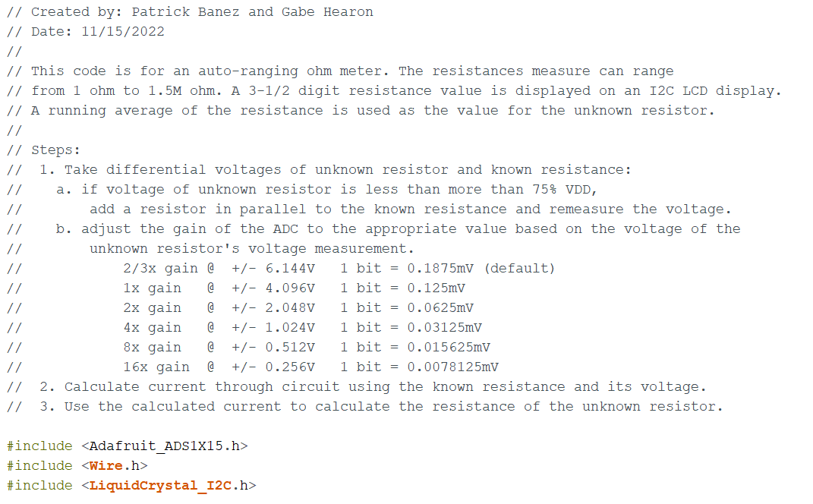

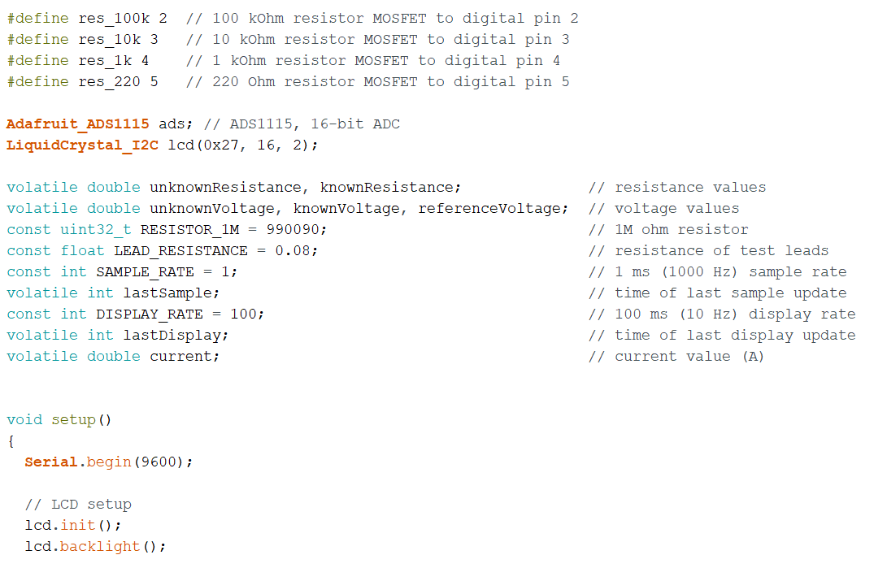

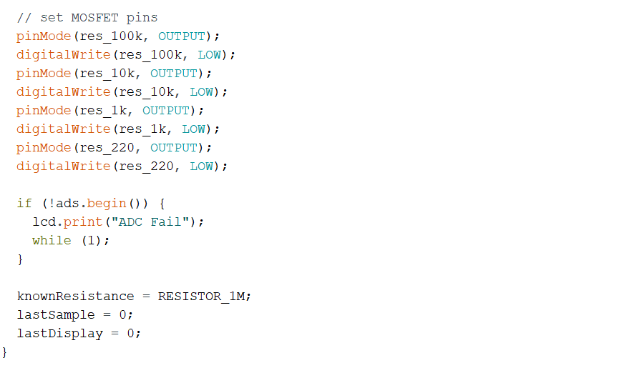

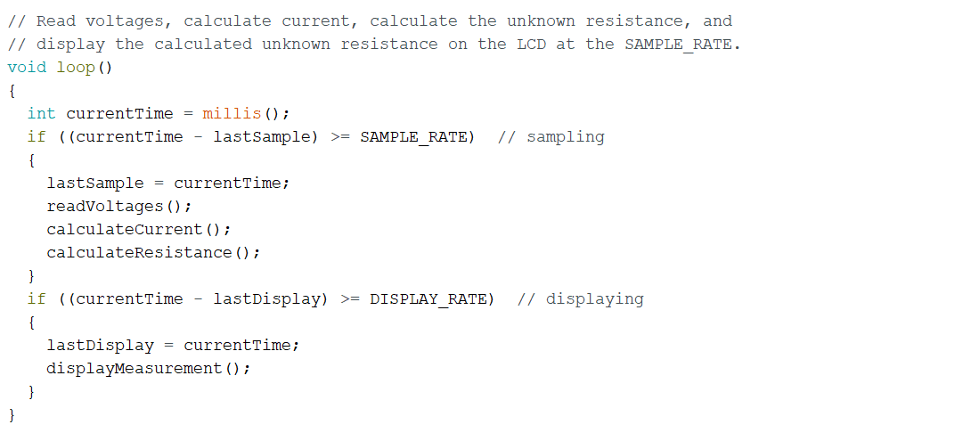

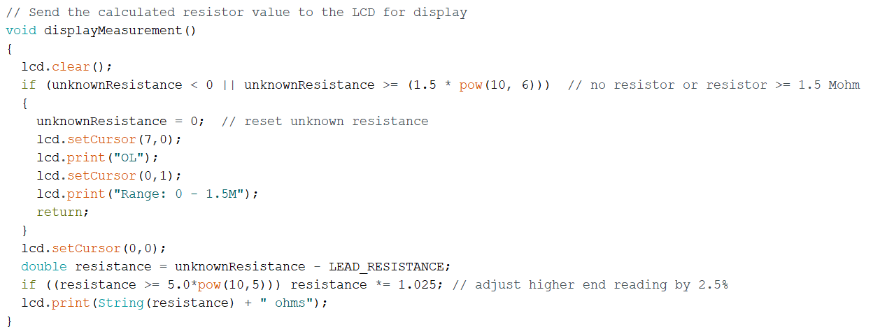

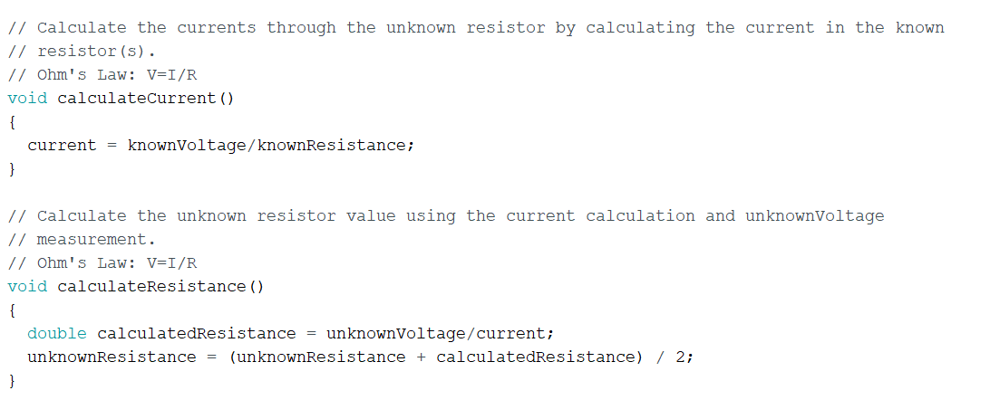

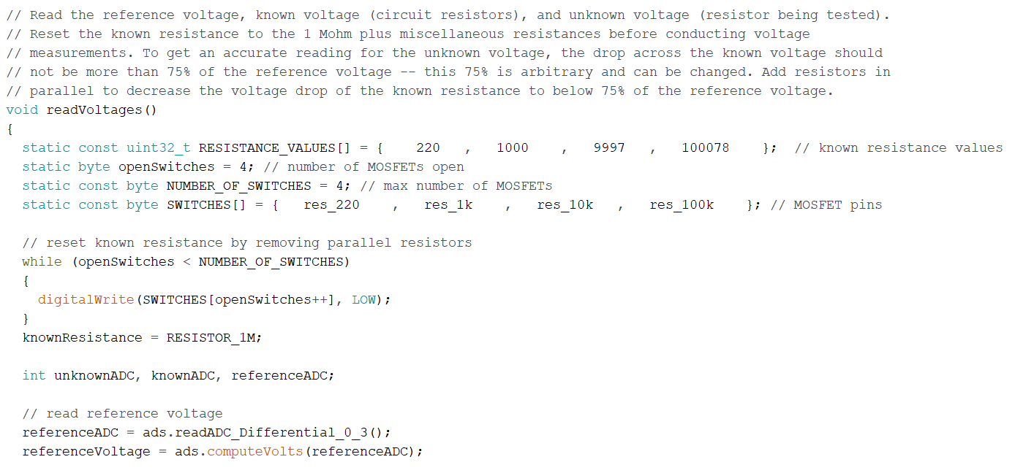

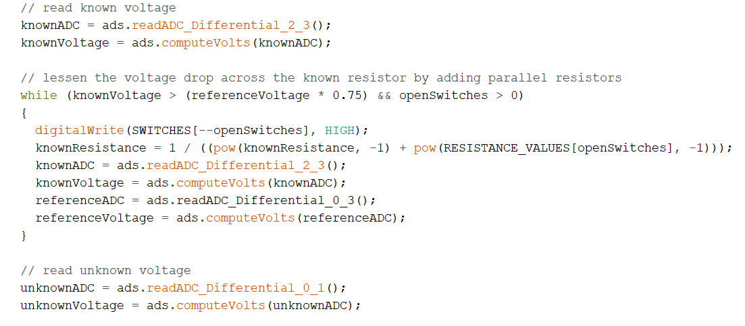

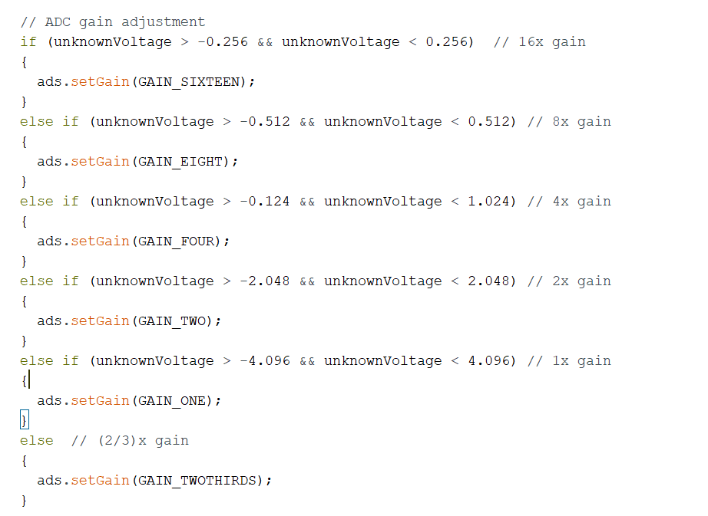

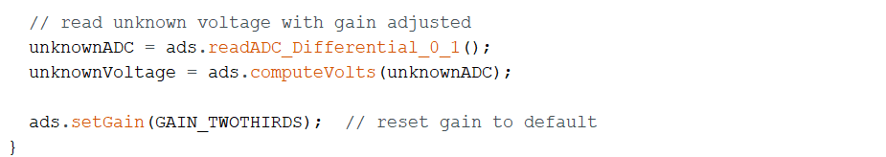

**Data Sheets**

MOSFET: <https://www.mouser.com/datasheet/2/916/PSMN017_30PL-2938824.pdf>

Reference Voltage: <https://www.mouser.com/datasheet/2/609/REF19xSeries-2956055.pdf>

Arduino Nano: <https://docs.arduino.cc/static/3352e3155813e4cada6a50b1ec6e10c9/A000005-datasheet.pdf>

ADC: <https://cdn-shop.adafruit.com/datasheets/ads1115.pdf>

**References**

# “TUTORIAL: How to / About the ADS1115 External 16 Bit ADC - Part 1.”, YouTube, Antony Cartwright, Apr 20 2018. <https://www.youtube.com/watch?v=oQ2lz2ZckRQ&t=405s&ab_channel=AntonyCartwright>

“I2C Liquid Crystal Displays.”, Arduino, arduino_uno_guy, Nov 13 2019. <https://create.arduino.cc/projecthub/arduino_uno_guy/i2c-liquid-crystal-displays-5b806c>

“Voltage regulator vs. voltage reference.”, Stack Exchange, GrixM, Mar 7 2016. <https://electronics.stackexchange.com/questions/221312/voltage-regulator-vs-voltage-reference>

**Appendix**

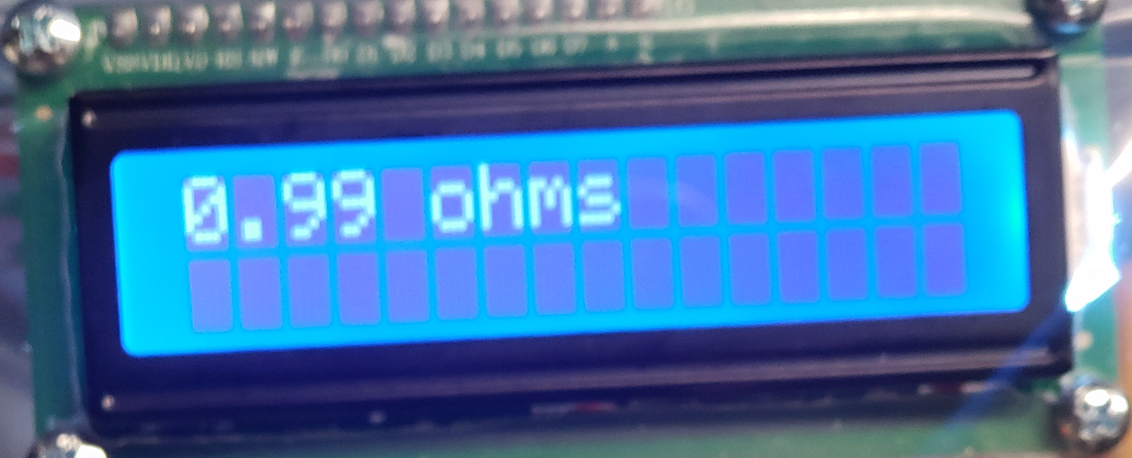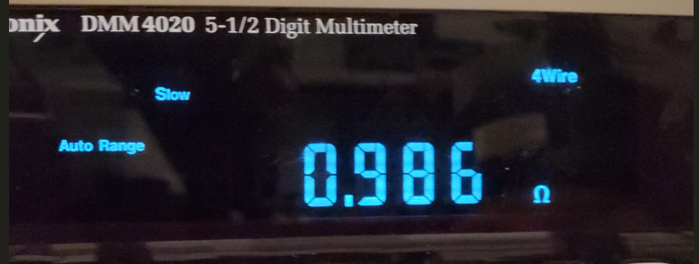

Appendix figure 1: 1Ω measurement

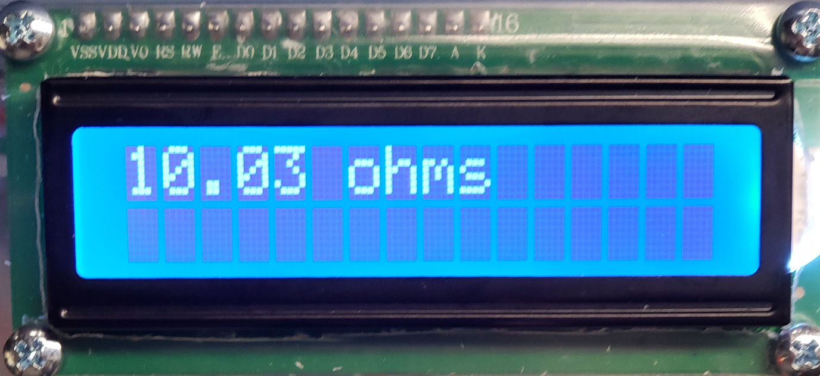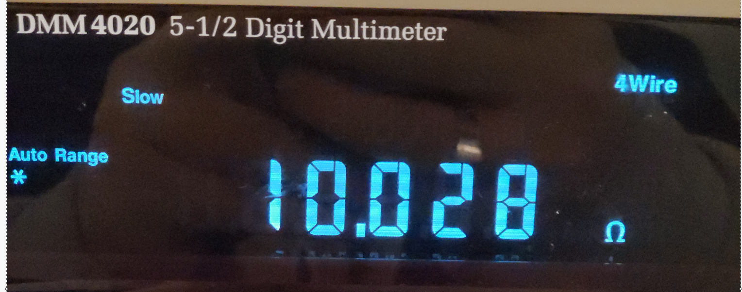

Appendix figure 2: 10Ω measurement

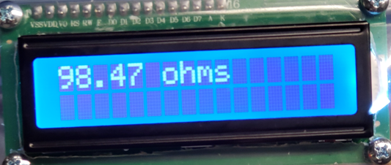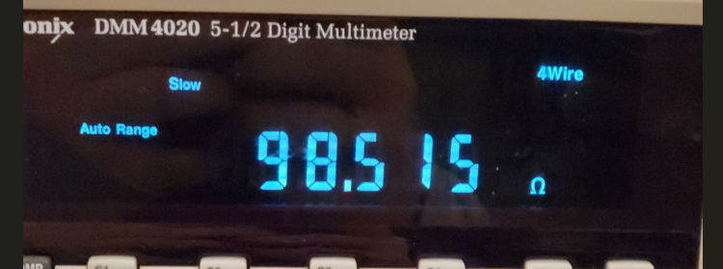

Appendix figure 3: 100Ω measurement

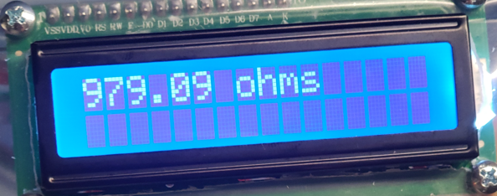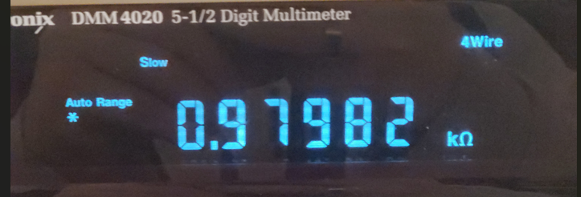

Appendix figure 4: 1 kΩ measurement

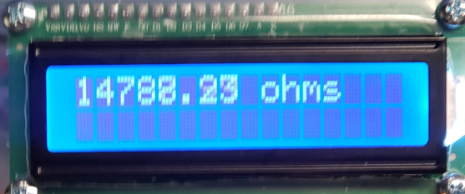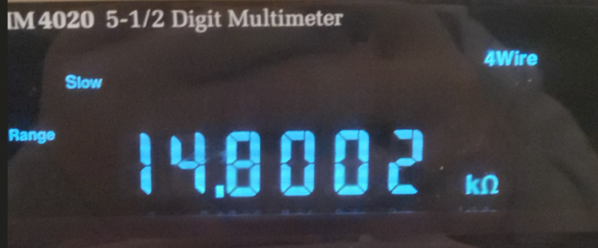

Appendix figure 5: 14.8kΩ measurement

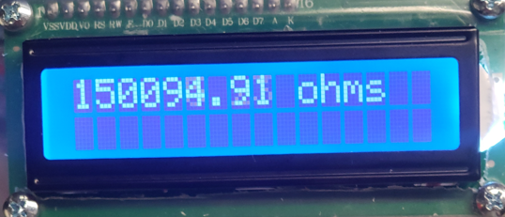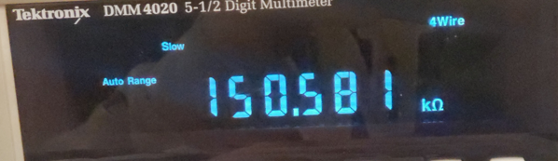

Appendix figure 6: 150kΩ measurement

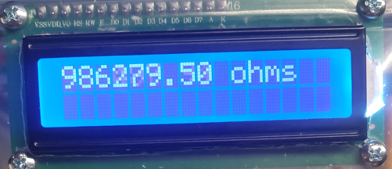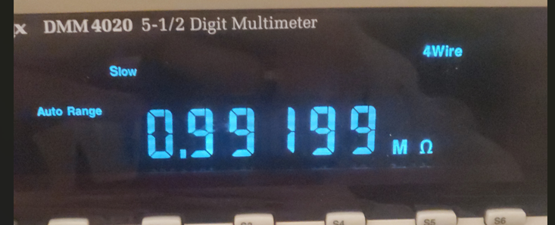

Appendix figure 7: 1MΩ measurement

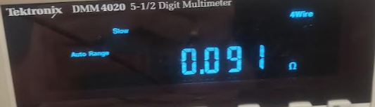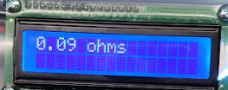

Appendix figure 8: 100mΩ measurement